**Compass**

The HMC5883L sensor is a 3-axis digital magnetometer IC designed for low-field magnetic sensing. The sensor has a full-scale range of +8 to -8 Gauss and a resolution of up to 5 milli-Gauss. Communication with the HMC5883L is simple and all done through an I2C interface. That means you will need to connect power, ground and only two cables to Arduino Uno board (SDA, SCL).

The HMC5883L board can be powered up by 5V or 3.3V pins of Arduino Uno board. No need to add any capacitors or resistors to your circuit.

Pinout and connection with Uno:

* Vcc to 5V or 3.3V
* GND to GND
* SDA to A4
* SCL to A5
* DRDY to nothing...

Because this is a magnetic compass if you put it near to battery, motors, metallic surface or magnetic field, the result will diverge from the actual.

The HMC5883L utilizes Anisotropic Magneto resistive (AMR) technology that provides advantages over other magnetic sensor technologies. These anisotropic, directional sensors feature precision in-axis sensitivity and linearity. These sensors’ solid-state construction with very low cross-axis sensitivity is designed to measure both the direction and the magnitude of Earth’s magnetic fields, from milli-gauss to 8 gausses.

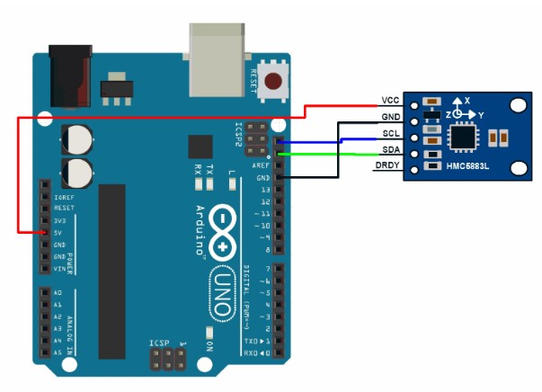

**GPS**

The Global Positioning System (GPS) is a satellite based navigation system that provides location and time information. The system is freely accessible to anyone with a GPS receiver and unobstructed line of sight to at least four of GPS satellites. A GPS receiver calculates its position by precisely timing the signals sent by GPS satellites.

GPS modules contain tiny processors and antennas that directly receive data sent by satellites through dedicated RF frequencies. From there, it’ll receive timestamp from each visible satellites, along with other pieces of data. If the module’s antenna can spot 4 or more satellites, it’s able to accurately calculate its position and time.

The four well-known Global Navigation Satellite System include GPS, BDS(Beidou), GLONASS and GALILEO four satellite navigation systems. The earliest appeared in the United States is GPS (Global Positioning System), which is the most complete technology at this stage. BDS, GLONASS and GALILEO have become the other largest satellite navigation systems in the world and are currently in the process of modernization.

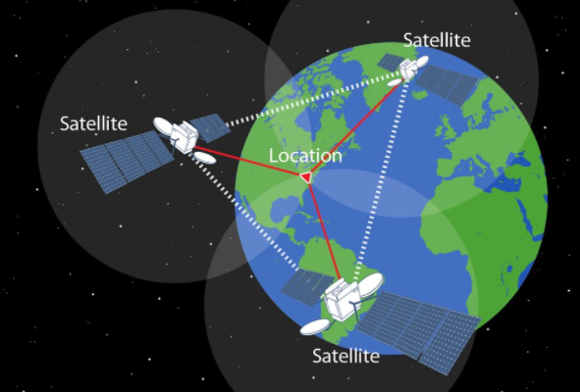

Figure satellite triangulation

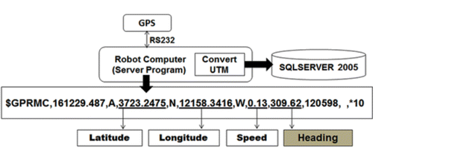

Figure 2 GPS Expectations

The first stage of the autonomous guidance algorithm determined the angle difference by comparing the current heading to the target azimuth. This step allowed the robot to determine what direction (left or right) it should turn. The next step determined the distance between the robot location and the target location. The robot program continuously calculates the distance and the minimum turn required. When the heading angle is equal to the azimuth angle, the robot is steered towards the destination point. When the distance is equal to zero, the robot arrives at the destination point

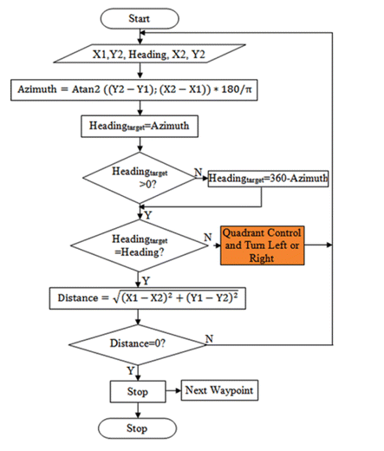

Figure 3 Autonomous robot guidance algorithm

A waypoint is the term used to describe a reference point for robot navigation. It includes destination latitude and longitude data. In this study, waypoints stored previously in the database were used for point-to-point steering in autonomous robot guidance. Two important angles called heading and azimuth angles were used to steer the robot autonomously. The heading angle was an angle between North (true or magnetic) and the current direction of the longitudinal axis of a robot in the horizontal plane. It was continuously received from the GPS receiver by the robot program. The azimuth was an angle between North and the destination point. It was continuously calculated by the robot program with Harvesine equation.

The **Haversine** formula calculates the shortest distance between two points on a sphere using their latitudes and longitudes measured along the surface. It is important for use in navigation.

The haversine can be expressed in trigonometric function as: 

$$haversine\left(θ\right)=\sin^{2}\frac{θ}{2}$$ The haversine of the central angle (which is d/r) is calculated by the following formula:



where r is the radius of the earth(6371 km), d is the distance between two points,  is the latitude of the two points, and  is the longitude of the two points respectively.  
Solving d by applying the inverse haversine or by using the inverse sine function, we get: 



or

